**Schematic Diagram**

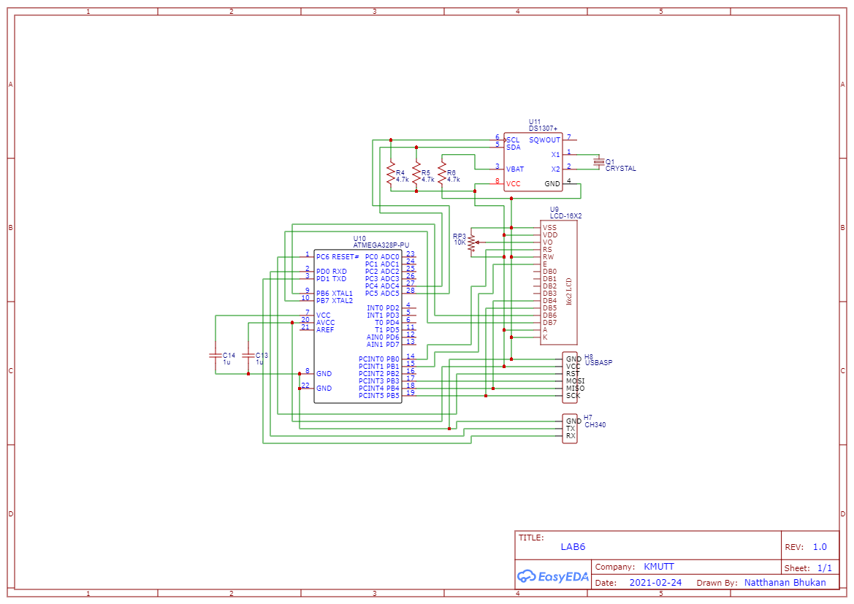

**Code**

**On board**

1. Connect a circuit with an ATMega328P and DS1307 (realtime clock IC) and write a program to display the current date and time on the 16x2 alphanumeric LCD screen

**Result**

